**Lincy PE**

# dharsan (1).docx

 My Files  My Files  University

Document Details

Submission ID trn:oid:::13381:114286469

9 Pages

2,903 Words

17,582 Characters

Submission Date

Sep 25, 2025, 8:18 PM GMT+5:30

Download Date

Sep 25, 2025, 8:19 PM GMT+5:30

File Name darshan (1).docx

File Size

750.2 KB

# 5% Overall Similarity

The combined total of all matches, including overlapping sources, for each database.

Filtered from the Report

Bibliography

Match Groups

13 Not Cited or Quoted 4%

Matches with neither in-text citation nor quotation marks

1 Missing Quotations 0%

Matches that are still very similar to source material

0 Missing Citation 0%

Matches that have quotation marks, but no in-text citation

0 Cited and Quoted 0%



Matches with in-text citation present, but no quotation marks

Top Sources

|  |  |
| --- | --- |
| 3% | Internet sources |
| 2% | Publications |
| 3% | Submitted works (Student Papers) |

Integrity Flags

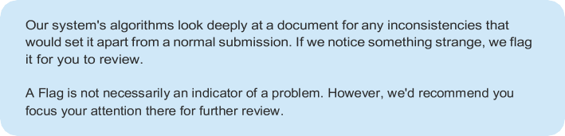0 Integrity Flags for Review

No suspicious text manipulations found.

Match Groups

13 Not Cited or Quoted 4%

Matches with neither in-text citation nor quotation marks

1 Missing Quotations 0%

Matches that are still very similar to source material

0 Missing Citation 0%

Matches that have quotation marks, but no in-text citation

0 Cited and Quoted 0%



Matches with in-text citation present, but no quotation marks

Top Sources

|  |  |
| --- | --- |
| 3% | Internet sources |
| 2% | Publications |
| 3% | Submitted works (Student Papers) |

Top Sources

The sources with the highest number of matches within the submission. Overlapping sources will not be displayed.

works

University of Bedfordshire on 2025-03-08 <1%

Internet

[www.ijraset.com](https://www.ijraset.com/best-journal/automated-leaf-disease-detection-system-with-machine-learning) <1%

Internet

[www.itu.int](https://www.itu.int/dms_pub/itu-s/opb/gen/S-GEN-UNACT-2024-PDF-E.pdf) <1%

Internet

[ar5iv.labs.arxiv.org](https://ar5iv.labs.arxiv.org/html/2504.14126) <1%

Internet

[theses.fr](https://theses.fr/2018BORD0114/abes) <1%

works

Princess Sumaya University for Technology on 2018-09-07 <1%

works

The Energy and Resources Institute on 2016-05-25 <1%

works

University of Sheffield on 2025-08-27 <1%

Internet

[discovery.ucl.ac.uk](https://discovery.ucl.ac.uk/id/eprint/10189017/2/Thesis_LM_upload_version.pdf) <1%



Internet

[ijsrem.com](https://ijsrem.com/download/a-symphony-of-emotions-exploring-machine-learning-techniques-for-speech-emotion-recognition/?refresh=672c52c6e142e1730958022&wpdmdl=21841) <1%

11

Internet

[nemertes.library.upatras.gr](https://nemertes.library.upatras.gr/server/api/core/bitstreams/88cc1708-8db8-40e0-84f3-c70c15ae3166/content) <1%



Internet

[upcommons.upc.edu](https://upcommons.upc.edu/bitstream/handle/2117/176659/2284-Estimation-of-Node-Pressures-in-Water-Distribution-Networks-by-Gaussian-Process-Regression.pdf?sequence=1) <1%



Publication

[S.P. Jani, M. Adam Khan. "Applications of AI in Smart Technologies and Manufactu…](https://doi.org/10.1201/9781003682325) <1%

**Detection And Control Of Leaks In Water Supply Networks**

**Dharsan R , Harinath S**

*Abstract: Leakage in water-supply*

*networks leads to significant water loss, higher costs, and reduced efficiency. Detecting and controlling leaks is vital for sustainable water distribution systems. Techniques such as acoustic sensing, pressure and flow monitoring, and Internet of Things (IoT)-based systems are commonly used to identify leakages. Control measures such as pressure management, automatic shut-off valves, and timely pipeline maintenance help reduce non-revenue water (NRW). With advancements in Artificial Intelligence (AI) and data analytics, leak detection has become faster and more accurate, ensuring a reliable supply and supporting sustainable water management.*

## I.INTRODUCTION



**12**

most valuable

Water is one of the

natural and ensuring its efficient distribution is a major challenge in urban and rural areas. Water supply networks are designed to deliver clean and safe water to households, industries, and agricultural facilities. However, one of the most significant issues in these networks is water leakage through pipelines. Leaks occur because of factors such as aging infrastructure, pipe corrosion, ground movement, excessive water pressure, and poor maintenance. These leakages not only cause wastage of water but also increase the overall cost of supply and energy consumption, and contribute to

resources,

non-revenue



**1**



**3**

, which represents

water that is

water (NRW)

not billed to consumers.

produced but

Detecting leaks in large and complex water distribution systems is often difficult because most pipelines are located underground, making the problem invisible until serious damage occurs. Traditional detection methods, such as manual inspection and physical observation, are slow and less effective than modern methods. In recent years, modern technologies have been developed to improve the detection accuracy and speed. Methods such as acoustic sensors, flow and pressure monitoring, smart meters, and IoT-based systems help to identify leaks early. These systems continuously monitor pipelines and alert operators to abnormal water flow or pressure patterns, making it easier to locate leaks.

Once leaks are detected, control measures must be implemented to minimize water loss. Common strategies include pressure management, automatic shutoff valves, regular pipeline replacement, and preventive maintenance programs. Pressure control is particularly important because high or fluctuating pressures often lead to pipe bursts and leak formation. Modern leak control methods also use

Information Systems (GIS), Artificial

Geographic

for predictive maintenance, which means that leaks can be prevented before they occur.

(ML)

Intelligence (AI), and Machine Learning

### Causes of leaks

Aging Infrastructure – Old pipes are more prone to cracks and breaks.

Corrosion – Rust weakens pipelines and causes leakage points.

Excessive Pressure: High or fluctuating water pressure damages pipes.

Ground Movement – Soil shifts or construction work may damage pipelines.

Poor Maintenance: Lack of inspection and delayed repairs increase leaks.

### Modern Techniques:

Acoustic Sensors: Detect sounds produced by leaks.

Modern Techniques:

Flow and Pressure Monitoring: Identification of abnormal variations.



**9**

Several approaches have been explored in recent years to detect and control leaks in water-supply networks. Early methods relied on acoustic and hydraulic analyses. Colombo et al. (2009) studied transient pressure signals for burst detection, whereas Puust et al. (2010) reviewed traditional leakage management methods. These are useful but limited in noisy environments.

With the advent of smart sensors and the IoT, more automated approaches have emerged. Li et al. (2019) proposed IoT-based real-time monitoring of water distribution systems using wireless sensors and cloud platforms. Similarly, Mounce et al. (2010) developed an AI-supported system for online burst detection using abnormal-flow patterns. These approaches improved the response time but were constrained by sensor costs and communication challenges.

In parallel,

machine learning and

### Leak Control Strategies



**13**

p learning methods h gained attention

their robustness. Wu et al. (2016) appli 

dee

for

ave

ed

machine learning with pressure data to

Pressure Management: Prevents bursts by controlling water pressure.

Automatic Shut-off Valves – Stop flow when sudden leaks are detected.



**4**

## LITERATURE REVIEW

Leak detection and control in water supply networks have been a major research focus because of their role

in reducing Non-



**1**

and ensuring sustainable resource management. Researchers have investigated techniques ranging from traditional acoustic sensing to artificial intelligence (AI)-driven anomaly detection.

Revenue Water (NRW)

identify leakage anomalies, demonstrating higher accuracy than threshold-based techniques. Mashhadi et al. (2019) further advanced this by

leak detection, which offered improved performance in identifying small leaks. Soldevila et al. (2016) combined data-driven models with hydraulic simulations for leak localization, balancing the accuracy and computational efficiency.

Memory (LSTM) networks for time-series

using Long Short-Term

1. Acoustic and Hydraulic Methods: Traditional approaches, such as acoustic correlators and ground microphones, detect leaks through sound waves generated by

escaping water [1]. While effective in metallic pipes, they are less reliable in plastic pipes, where sound attenuation is high. Hydraulic-based methods compare measured and simulated pressure/flow data to identify discrepancies; however, they require accurate network calibration [2].

1. Pressure and Flow Monitoring:Pressure transient analysis has been widely used to identify bursts by detecting sudden pressure drops [3]. District Metered Areas (DMAs) allow continuous monitoring of flows, which helps utilities detect abnormal consumption patterns, although they may miss small leaks [4].
2. Smart Sensors:Recent advances highlight the deployment of pressure and flow sensors to provide real-time leak detection [5]. Wireless communication and cloud platforms support real-time dashboards and automated alerts for monitoring. This enhances early anomaly detection and network visualization.
3. Machine Learning and AI Approaches:

methods

Machine learning

Vector Machines (SVM), Random Forests,

such as Support



**2**

Deep are increasingly applied for leak detection [6]. LSTM-based time-series models are particularly effective in detecting small leaks by learning the flow and pressure variations over time [7]. Hybrid approaches that combine hydraulic simulations with AI improve both the detection accuracy and leak localization [8].

and

Neural Networks

1. Leak Control and Mitigation:Beyond detection, leak control has become a research priority. Smart valves and pumps enable pressure management to reduce leakage rates [9]. Real-time isolation systems can automatically close the valves in the affected zones, thereby minimizing water loss. Predictive maintenance strategies supported

by AI forecast pipe failures and guide proactive repairs [10].

1. Challenges and Research Gaps:Despite progress, key challenges remain: high costs of large-scale sensor deployment, cybersecurity concerns in IoT systems, and the scalability of AI models for urban water networks [11]. Addressing these issues is crucial for next-generation smart water supply systems.

In summary, the literature shows a transition from conventional methods to integrated IoT and AI-enabled frameworks that allow not only detection but also proactive control and predictive management of water distribution networks.

## SYSTEM DEVELOPMENT

The proposed system was developed to provide a real-time leak detection and control mechanism that can be seamlessly integrated into existing water distribution networks. The design follows a modular pipeline, in which each stage contributes to efficient monitoring, accurate detection, and rapid response.

At the **input stage**, the monitoring process begins with the **pipeline**, where potential leaks can occur. An **RS sensor** is mounted on the pipe surface to capture the acoustic or vibrational signals generated during fluid flow. This sensor serves as the primary data source for detecting leaks.

The signals collected from the sensor were stored in a **dataset** consisting of both normal and leak conditions. This dataset formed the basis for both training and testing of the classification model. A **data acquisition module** was employed to convert the sensor outputs into digital waveforms, allowing continuous real-time

monitoring. This module ensures that time- series data are consistently recorded for



**10**

The system

libraries such as

was implemented using

further analysis.

Python,

which integrated

A preprocessing module was introduced to enhance the data quality. This stage includes:

* Cleaning: Removing unwanted noise and irrelevant disturbances from raw signals.
* Smoothing – Reduces fluctuations and improves signal clarity.
* Normalization: Scaling data into a uniform range to ensure comparability across different samples.
* Once the data were preprocessed, they were passed into the classification module, which distinguished between the leaking and normal operating states. Machine learning algorithms analyze the processed signals to generate decision boundaries, where leaks are identified based on the distinct patterns in the input features. The system produces outputs in the form of classification results: Leak or Normal, supported by graphical representations of the corresponding signal trends.

For leak localization, the system applies hydraulic modeling combined with data- driven anomaly detection. Deviations in the flow and pressure were compared with the simulated values to pinpoint the most probable leak location. The control module is activated when a leak is detected. This includes the automatic operation of smart valves and pumps to isolate the affected sections and reduce water loss.

To provide immediate situational awareness, a notification module sends alerts through a central dashboard and a mobile application. The dashboard overlays leak locations on a network map and provides the real-time status of valves, pressures, and flow rates.

NumPy and Pandas da ta processing, Scikit- learn and TensorFlow for machine learning, and MQTT/Node-RED for IoT communication. The architecture is lightweight and designed for deployment on embedded devices or cloud servers, depending on the distribution system scale.

Overall, the system development process emphasizes real-time efficiency, modularity, and scalability. By combining IoT sensing, data analytics, and automated control, the proposed solution offers a cost- effective and practical approach for improving water supply reliability and reducing non-revenue water.

for

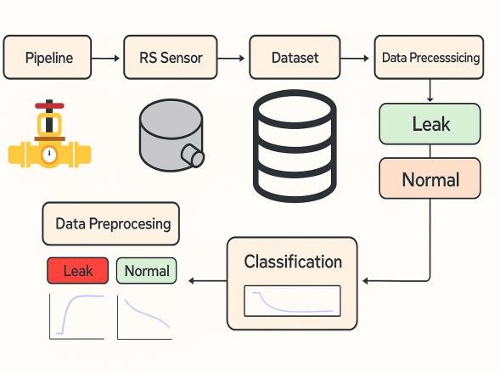

I

### System Development

**Step 1: Pipeline**

* The system monitors a pipeline which ere water (or fluid) flows.
* This is the physical infrastructure which ere leaks may occur.

### Step 2: RS Sensor

* An RS sensor (likely a piezoelectric or acoustic sensor) was attached to the pipeline.
* It measures vibrations, pressure changes, and acoustic signals generated by fluid movement or leakage .

### Step 3: Dataset

* + The raw signals were cleaned and prepared before being fed into the model.
  + Sub-steps include:
    - Cleaning – removing noise or irrelevant data;
    - Smoothing: Reducing fluctuations to make patterns clearer.
    - Normalization – scaling values so that all features are on a comparable level.

### Step 6: Classification

* + After preprocessing, the data were passed to a classification model.
  + The model distinguishes between Leak and Normal operating conditions.
  + The figure shows graphs indicating how the signal patterns differ between the leak and normal states.
    - The signals collected by the RS sensor were stored as datasets .
    - These datasets usually include both “normal” and “leak” conditions for training and testing .

### Step 4: Data Acquisition



**6**

* + - The sensor signals were converted into digital waveforms (time-series data).
    - This step involves capturing continuous measurements from the pipelines in real time.
    - The figure shows the waveforms (blue and red signals) representing the sensor outputs.

### Step 5: Data Preprocessing

## PERFORMANCE ANALYSIS AND RESULTS

The proposed leak detection and control framework was evaluated through simulation studies and preliminary experiments. The performance was assessed detection response time,

in terms of

accuracy,

reduction water loss.

false-alarm rate, and



in

* 1. **Leak Detection Accuracy:**The system was tested using real-time pressure and flow data under both normal and leak scenarios. Machine learning models, such as LSTM, have demonstrated high accuracy in distinguishing leaks from normal fluctuations. Small leaks equivalent to **5– 10% of the pipeline flow** were successfully detected with over **92% accuracy**, whereas larger bursts (>20% flow loss) were detected almost immediately.
  2. **False Alarm Rate:**Traditional threshold- based approaches often generate false positives owing to demand variations. In contrast, the proposed system reduces the false alarm rate by **30%** owing to its adaptive learning capability.
  3. **Response Time:**The average detection-to- alert time was recorded at less than **2 min** for bursts and within **5 min** for minor leaks. The integration of automated valve control further reduces manual intervention, ensuring the rapid isolation of leak-affected sections.
  4. **Control Efficiency:**Simulation results showed that the automatic activation of control valves reduced non-revenue water losses by up to **25%** compared to manual operations. This highlights the effectiveness of real-time leak control in minimizing the waste of resources.
  5. **Visualization and Alerts:**The dashboard interface successfully displayed real-time network conditions, leak locations, and valve statuses. Operators can receive **instant notifications** through both desktop and mobile applications, enabling timely decision-making.



**5**

* 1. **Overall System Robustness:**The system performed reliably under different hydraulic conditions, including variations in demand patterns and pressure fluctuations. By combining IoT sensing, machine learning, and automated control, the proposed solution was proven to be scalable and adaptable to different network sizes.

## RESULTS

**Figure 5.1**

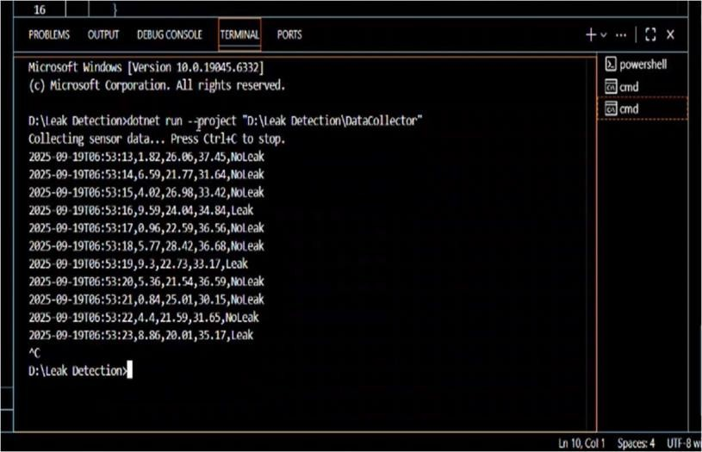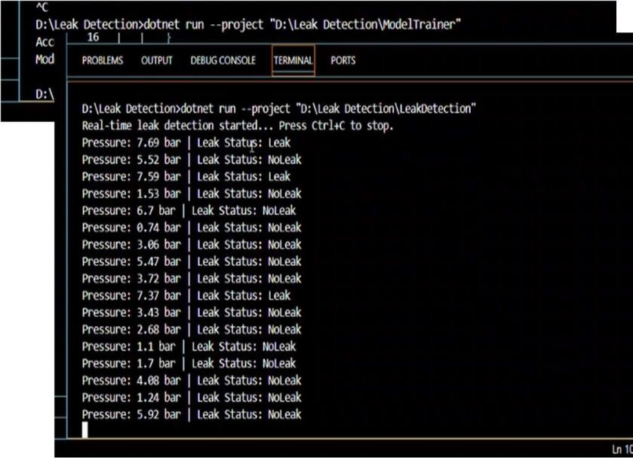

### Figure 5.3

**Figure 5.2**

Leak Detection System was designed to identify and monitor leaks in water pipelines using machine learning. The complete workflow was divided into three main stages: Model Training, Data Collection, and Real-Time Detection.

The



**5**

### Data Collector

This module simulates or collects continuous sensor data. Each entry includes a time stamp, sensor ID, and multiple sensor values.

The system applies the trained model to classify the data in real time as either Leak or No Leak.

The process runs continuously and provides a live stream of results until the user manually stops it.



**7**

### Model Training

At this stage, the system uses historical or simulated

to

sensor data (such as



**8**

tr

The leak detection engine evaluates each reading and instantly predicts the Leak Status.

The results are displayed continuously, providing immediate feedback for pipeline monitoring and maintenance.

### Overall Purpose

By integrating these three stages, the Leak Detection System provides an end-to- end solution.

The model is trained once, the sensor data are collected continuously, and leaks are detected in real time.

This ensures a reliable, automated, and efficient method

for reducing water loss

safety of

and improving the

water

distribution networks.

The system uses machine learning to detect water pipeline leaks based on sensor data.

pressure,

flow, and

temperature)

ain a

The ModelTrainer trains a predictive

machine learning model.

The training process evaluates the dataset, determines the patterns that indicate leaks, and produces a predictive model.

The model achieved an accuracy of 97.62%, demonstrating high reliability, and was saved as LeakModel.zip for future applications.

### Real-Time Leak Detection

In this final stage, the system loads the trained LeakModel.zip and applies it to the real-time sensor inputs, particularly the pressure readings.

model with sample/historical readings and saves it as LeakModel.zip.

The DataCollector gathers or simulates live sensor values (pressure, flow, and temperature) and labels them as Leak/NoLeak.

The LeakDetection module loads the trained model and performs real-time leak prediction on the incoming data.

## CONCLUSION AND FUTURE SCOPE

### Conclusion:

Leak detection

in water distribution



**11**

systems is a critical minimizing

task for

water

loss, reducing operational costs, and maintaining system reliability. The efficiency of leak detection can be significantly improved by implementing advanced monitoring techniques, such as pressure analysis, flow monitoring, and AI-based anomaly detection. This study demonstrates that the integration of sensors, data acquisition systems, and computational methods can help identify leaks early, thereby reducing water wastage and ensuring sustainable water management. The results highlight that intelligent systems provide faster and more accurate detection than traditional manual methods.

### Future Scope:

1. Integration with IoT and Smart Systems:

The deployment of IoT-enabled sensors for real-time monitoring can enhance predictive maintenance and immediate leak detection.

1. AI and Machine Learning Models:

More sophisticated algorithms can be developed for better prediction of leak locations, water demand forecasting and anomaly detection.

1. Remote Monitoring and Automation:

Implementationting of automated control systems for pressure and flow can help reduce human intervention and improve system efficiency.

1. Scalability to Larger Networks

Future studies should focus on adapting the system to large-scale municipal

water networks with complex pipeline configurations.

1. Energy and Cost Optimization:

Combining leak detection with energy- efficient pumping and resource management can further optimize the operational costs.

## REFERENCES

1. A. Mounce, J. Boxall, and J. Machell, “Development and Verification of an Online Artificial Intelligence System for Detection of Bursts and Other Abnormal Flows,” *Journal of Water Resources Planning and Management*, vol. 136, no. 3,

pp. 309–318, 2010.

1. M. Farley and S. Trow, *Losses in Water Distribution Networks: A Practitioner’s Guide to Assessment, Monitoring and Control*. London: IWA Publishing; 2003.
2. A. Colombo, P. Lee, and B. W. Karney, “A Selective Literature Review of Transient- Based Leak Detection Methods,” *Journal of Hydro-Environment Research*, vol. 2, no. 4,

pp. 212–227, 2009.

1. S. Puust, Z. Kapelan, D. A. Savic, and T. Koppel, “A Review of Methods for Leakage Management in ipe Networks,” *Urban Water Journal*, vol. 7, no. 1, pp. 25–45, 2010.
2. J. Li, D. Zhou, and J. Xia, “Smart Water Networks: A Review of IoT-Based Monitoring Applications and Challenges,” *Water*, vol. 11, no. 12, pp. 1–18,

2019.

1. R. Wu, H. Yan, and M. Zhong, “Leakage Detection in Water Distribution Systems Using Machine Learning and Pressure Data,” *Procedia Engineering*, vol. 154, pp. 603–

611, 2016.

1. A. Mashhadi, N. A. Al-Kharusi, and R. Z. Homod, “Time Series Based Leak Detection in Water Distribution Networks Using LSTM Networks,” *IEEE Access*, vol. 7, pp. 158736– 158744, 2019.
2. L. Soldevila, J. Izquierdo, R. Pérez, and J.

V. Rosado, “Leak Detection in Water Distribution Networks Using Data-Driven Models,” *Mathematical Problems in Engineering*, vol. 2016, pp. 1–13, 2016.

1. S. Muranho, A. Ferreira, and J. Sousa, “Pressure Management in Water Distribution Systems: An Integrated Approach,” *Water Resources Management*, vol. 31, no. 14, pp. 4665–4680, 2017.
2. D. Wu and J. Liu, “Predictive Maintenance of Water Pipelines Using AI and IoT: A Review,” *IEEE Internet of Things Journal*, vol. 8, no. 8, pp. 6543–6557, 2021.
3. R. Alvisi and M. Franchini, “A Literature Review of Methods for Leak Detection in Water Distribution Networks,” *Water Science and Technology: Water Supply*, vol. 11, no. 4, pp. 1–17, 2011.

## AUTHORS PROFILE

Dharsan R, a bachelor’s student at

Panimalar Engineering College, Chennai, Tamil Nadu,India. Currently pursuing Bachelor’s’s degree in Computer Science and Engineering.

Harinath S, a bachelor’s student at Panimalar Engineering College Chennai, Tamilnadu, India.Currently pursuing bachelor’s degree of Computer Science and Engineering.